From Principal Dimensions to Full Hydrodynamic Characterization: A Machine Learning Methodology

Abstract
The preliminary design phase in naval architecture is characterized by a trade-off between rapid, low-fidelity empirical methods and time-consuming, high-fidelity physics-based simulations. This creates a significant gap for a tool that can facilitate comprehensive and rapid design space exploration. This study introduces a novel, data-driven framework designed to bridge this gap. By leveraging a foundational, public-domain dataset derived from systematic model testing, we develop a comprehensive, cascading predictive tool. The proposed framework is capable of generating a full suite of geometric and hydrodynamic parameters from a minimal set of principal dimensions. This approach moves beyond the narrow focus of previous data-driven applications in the field, which have typically been limited to single performance metrics or specific vessel types. The aim is to provide a holistic tool that enhances the traditional design spiral, enabling robust and efficient exploration of design candidates in the early stages of development.
Keywords: Naval Architecture, Preliminary Design, Data-Driven Design, Hydrodynamics, Machine Learning, Hull Form, Design Space Exploration, Predictive Modeling.

1. Introduction
The preliminary design phase in naval architecture is a critical stage where foundational decisions regarding a sailing yacht's hull form are made. These initial decisions dictate the vessel's fundamental performance characteristics, including its hydrodynamic resistance, stability, and handling. The process is traditionally iterative, often described by the "design spiral," where designers methodically refine parameters to achieve an optimal balance between these often-competing attributes. The efficacy of this process is highly dependent on the tools available to the designer for evaluating the performance of each design iteration.
Despite its established nature, the traditional design process is beset by significant limitations that can stifle innovation and prolong development timelines. A heavy reliance on historical data and empirical formulas often confines the designer to a narrow, well-documented design space, making it difficult to explore novel concepts. Conversely, high-fidelity methods such as Computational Fluid Dynamics (CFD) and physical model testing, while accurate, are computationally expensive and time-consuming, rendering them impractical for the rapid evaluation of numerous concepts in the early design stages. This presents a fundamental problem: a lack of tools for rapid, holistic, and data-informed analysis in the crucial initial design phase.
To address this gap, this paper introduces a novel, AI-driven framework for the comprehensive parametric prediction of a sailing yacht's geometric and hydrodynamic characteristics. This data-driven approach leverages a cascade of machine learning models trained on the well-regarded Delft Systematic Yacht Hull Series. The core innovation of this framework lies in its ability to generate a full suite of over 30 performance parameters—encompassing detailed hull geometry, resistance across a range of speeds, stability, and other advanced metrics—from only three principal inputs: overall length (L), beam (B), and draft (T).
The primary objectives of this research are therefore to:
- Develop a cascading machine learning framework to accurately predict a yacht's full geometric definition from its principal dimensions.
- Create a hybrid predictive model for hydrodynamic resistance by combining a machine learning-based predictor for residuary resistance with an analytical formula for frictional resistance.
- Extend the framework to predict a suite of advanced performance characteristics, including stability, leeway, and heeled resistance.
- Rigorously validate the performance of all developed models against the original experimental data to confirm their accuracy and reliability.
The remainder of this paper is organized as follows. Chapter 2 provides a review of the relevant literature concerning traditional design methods and the application of AI in naval architecture. Chapter 3 details the complete methodology, including the data preparation, model architecture, and training processes. Chapter 4 presents and discusses the validation results for the geometric, resistance, and advanced characteristic models. Finally, Chapter 5 offers concluding remarks on the significance of the work and suggests directions for future research.

2. Literature Review
This chapter provides a review of the established methods in preliminary yacht design, formally introduces the foundational dataset used in this study, and situates the current research within the context of existing applications of artificial intelligence in naval architecture.
The traditional approach to preliminary yacht design is often described by the "design spiral," an iterative process wherein key parameters are progressively refined. As illustrated in Figure 1, this process has historically been supported by a range of tools that represent a trade-off between speed and fidelity. At one end of the spectrum are empirical formulas and regression-based methods derived from historical data of previous designs. While these methods are fast and computationally inexpensive, their applicability is often limited to the specific hull forms for which they were developed, and they can be inaccurate when applied to novel concepts outside of their original scope. At the other end of the spectrum are high-fidelity physics-based simulations, primarily Computational Fluid Dynamics (CFD). While CFD provides detailed insight into the fluid dynamics around a hull, it is computationally prohibitive and time-consuming, making it unsuitable for the rapid evaluation of the large number of design candidates typical of the early design phase. This creates a significant gap for a tool that is both rapid and comprehensive.
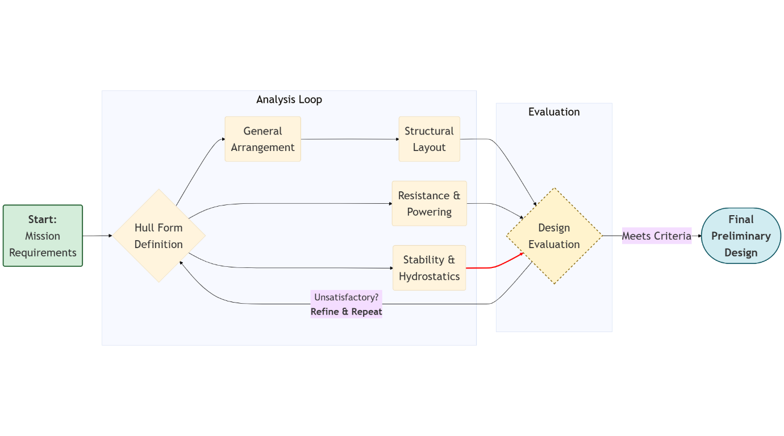
Figure 1: This figure illustrates the traditional "design spiral," showing the iterative process of yacht design where key parameters are progressively refined in a cyclical workflow, moving from initial concepts to detailed analysis.

The primary source of data for this study is the seminal work on the "Geometry, Resistance and Stability of the Delft Systematic Yacht Hull Series" conducted at the Delft University of Technology. This public-domain dataset is one of the most comprehensive and widely respected benchmarks in the field. It was generated through rigorous physical model testing in a towing tank on a series of 22 yacht hulls. These models were created by systematically varying key design ratios—such as the longitudinal center of buoyancy and the length-to-displacement ratio—from a parent hull form. The resulting dataset is exceptionally rich, containing not only the detailed hull form geometry for each model but also the experimental results for upright resistance, heeled resistance, stability, and sideforce generation. Its systematic nature and public availability have made it the standard for validating new hydrodynamic prediction methods.
In recent years, artificial intelligence (AI) and machine learning (ML) have seen growing application in the field of naval architecture. These data-driven techniques have been successfully applied to a variety of specific problems, such as predicting the resistance of bulk carriers and container ships, optimizing hull forms for a single objective using genetic algorithms, and modeling vessel maneuvering characteristics. These studies, while valuable, have typically maintained a narrow focus, often predicting a single performance metric or being constrained to a specific vessel type. A comprehensive, cascading framework capable of generating a full suite of geometric and hydrodynamic parameters from a minimal set of principal dimensions—thereby enabling true holistic design exploration—has not yet been presented in the literature. This study aims to fill that gap by leveraging the high-quality Delft dataset to train such a predictive tool.

3. Methodology
The methodology presented in this research establishes a novel, AI-driven framework for the comprehensive prediction of a sailing yacht's geometric and hydrodynamic characteristics from a minimal set of principal dimensions. This approach moves beyond traditional regression-based formulas by leveraging machine learning to create a holistic model of the vessel. The core objective is to accurately derive a full suite of parameters—encompassing detailed hull form geometry, resistance across various speeds, stability, and heeled performance—using only the overall length (L), beam (B), and draft (T) as initial inputs. The entire predictive framework is developed and validated using the public-domain data from the seminal research on the "Geometry, Resistance and Stability of the Delft Systematic Yacht Hull Series," which provides exhaustive geometric and experimental test data for 22 systematically varied yacht models that serve as the ground truth for training and evaluating the machine learning models.
The methodology is executed as a structured, multi-stage process. The process begins with the sourcing, extraction, and structuring of the numerical data from the Delft Yacht Hull Series report. Following data preparation, a cascading prediction approach is employed for geometric parameter prediction, where an initial correlation analysis and subsequent machine learning models are used to iteratively determine over 30 geometric parameters. Subsequently, the methodology addresses hydrodynamic resistance prediction, detailing the process for modeling residuary resistance via machine learning and calculating total resistance using the ITTC 1957 friction line. Finally, the framework is completed by outlining the development of discrete models for predicting advanced performance characteristics, including residuary stability, leeway characteristics, and heeled resistance.

3.1. Data Source and Preparation
The sole source of empirical data for this study is the "Geometry, Resistance and Stability of the Delft Systematic Yacht Hull Series" report. This data originates from physical model testing conducted in a towing tank facility at Delft University. The series' 22 yacht models were methodically developed by systematically altering key design ratios from a parent hull form, ensuring a logical variation across the design space. Each physical model was then subjected to a rigorous experimental campaign, where it was towed at a range of controlled speeds while dynamometers measured the resulting hydrodynamic forces. From this experimental program, the primary data utilized in our study includes the full set of hull form parameters and the residuary resistance coefficients, which were recorded for each model at 14 discrete Froude numbers, yielding 308 unique resistance data points. To facilitate a more holistic performance model, the dataset was further expanded to include advanced hydrodynamic characteristics measured during these tests, such as the yacht's dimensionless residuary stability curves, the relationship between leeway angle and hydrodynamic sideforce, and the added resistance coefficients resulting from various angles of heel. To make this information computationally accessible, all relevant numerical data from the report's tables was systematically digitized and compiled into a structured database, forming the foundational dataset for the subsequent machine learning pipeline.

3.2. Geometric Parameter Prediction: A Cascading Methodology
The prediction of the yacht's complete geometry is achieved through a cascading methodology, where the set of known parameters is iteratively enriched. The process begins with only three primary inputs: overall length (L), beam (B), and draft (T). An initial correlation matrix containing all geometric parameters from the Delft dataset was computed to guide the prediction strategy, identifying the strength of relationships between variables and informing the choice of modeling technique for each parameter, as shown in the heatmap in Figure 2. The overall workflow of this cascading process, from initial inputs to the final dataset, is visually summarized in Figure 3.
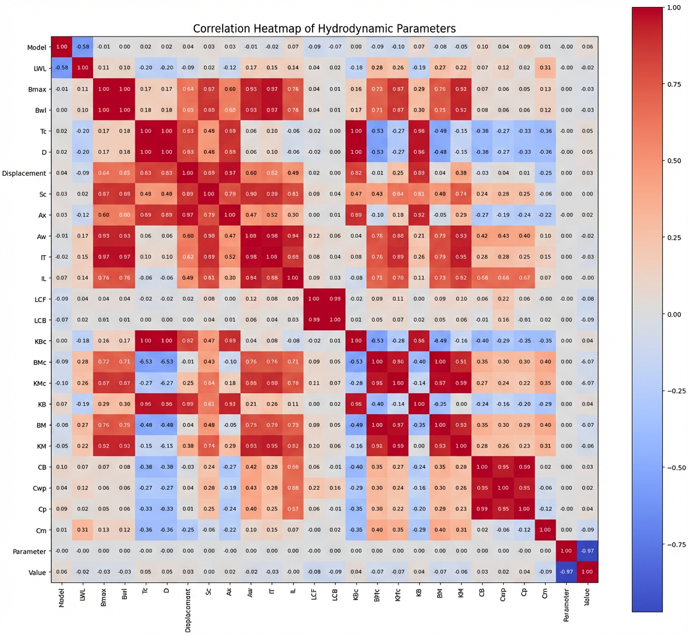
Figure 2: Correlation Matrix Heatmap of Geometric Parameters.

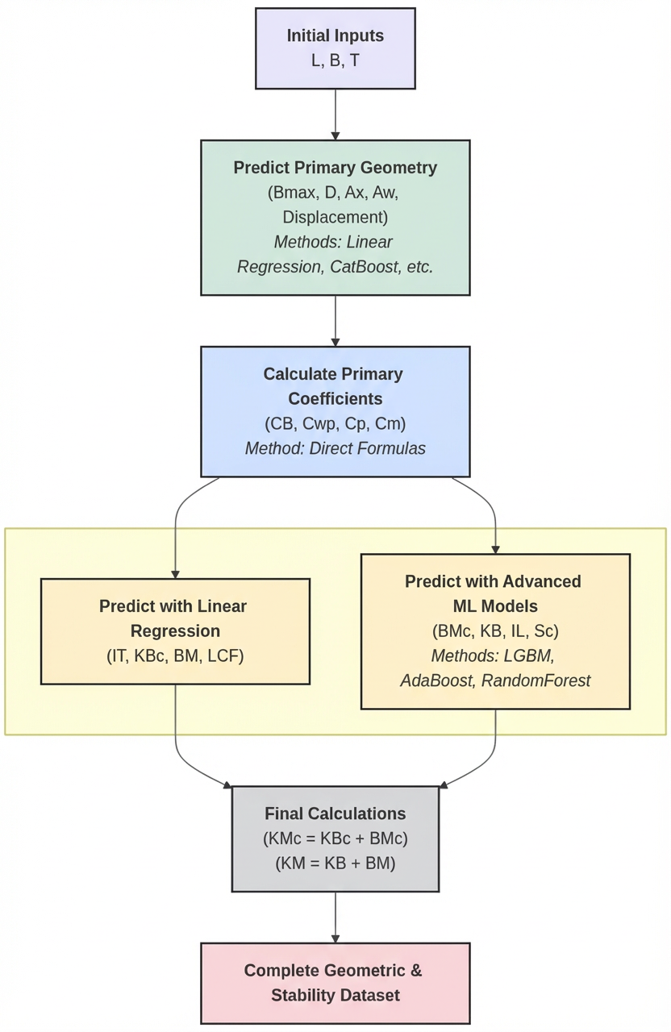
Figure 3: Flowchart of the Cascading Geometric Prediction Methodology.
The first stage of the cascade addresses parameters with exceptionally high correlations. For instance, the maximum beam (Bmax) and moulded depth (D) exhibit near-perfect correlations (coefficient ≈ 1.0) with the waterline beam (Bwl, derived from B) and canoe body draft (Tc, derived from T), respectively. For these, a simple linear regression model was sufficient to achieve high-accuracy predictions. Following this, the midship section area (Ax) was predicted, which showed strong correlations of 0.89 and 0.60 with Tc and Bwl, respectively, and was also effectively modeled using linear regression. Crucially, each newly predicted parameter was immediately appended to the set of available features for subsequent, more complex modeling steps.
The next parameter addressed was the waterplane area (Aw). Its correlations with Lwl and Bwl were 0.17 and 0.93. The notably low correlation with Lwl is attributed to the very narrow range of Lwl values (10.0m to 10.15m) across the 22 models in the dataset, which limits its statistical significance. Due to this more complex relationship, a more powerful gradient boosting model, CatBoost, was employed to ensure an accurate prediction. Similarly, the vessel's Displacement was predicted using L, B, and T (correlations of 0.09, 0.65, and 0.83), also leveraging a sophisticated machine learning model to capture the non-linearities.
With a foundational set of primary and secondary geometric parameters now established (L, B, T, Aw, Ax, Displacement), several key naval architecture coefficients could be derived directly through their definitional formulas, requiring no predictive modeling. These included the Block Coefficient (CB = Displacement / (L * B * T)), the Waterplane Area Coefficient (Cwp = Aw / (L * B)), the Prismatic Coefficient (Cp = Displacement / (Ax * L)), and the Midship Section Coefficient (Cm = Ax / (B * T)).
The process continued by modeling the remaining geometric and stability-related parameters. The Longitudinal Center of Flotation (LCF) was predicted from the Longitudinal Center of Buoyancy (LCB) using linear regression, leveraging their 0.78 correlation. The wetted surface area (Sc) was predicted using Lwl, Bwl, Tc, and CB as inputs. The transverse inertia (IT) and the vertical position of the center of buoyancy (KBc) were modeled with linear regression due to their high correlations (0.89) with Aw and Tc, respectively. More complex parameters required more advanced algorithms: the transverse metacentric radius (BMc) was predicted using an LGBMRegressor model with Lwl, Bwl, and Aw as inputs; the vertical center of buoyancy (KB) was modeled with an AdaBoost algorithm using Tc, Ax, and Displacement; and the longitudinal metacentric radius (IL) was predicted with a RandomForestRegressor using Lwl, Bwl, and Aw. Finally, two parameters were calculated directly: the transverse metacentric height above baseline (KMc) as KMc = KBc + BMc, and the total transverse metacentric height (KM) as KM = KB + BM, where BM was predicted from BMc via linear regression due to their perfect correlation.
To ensure optimal performance for all machine learning models (CatBoost, LGBM, AdaBoost, RandomForest), the Grid Search technique was systematically applied. This method exhaustively explored a defined hyperparameter space for each algorithm to identify the combination that yielded the highest predictive accuracy. A complete summary detailing the chosen prediction method and the corresponding input features for each parameter in this geometric cascade is presented in Table 1.

Table 1: Summary of Prediction Models for Geometric and Stability Parameters
Target Parameter | Prediction Method Algorithm | Input Features
Bmax, D | Linear Regression | Bwl, Tc
Ax | Linear Regression | Bwl, Tc
Aw | CatBoost | Lwl, Bwl
Displacement | Machine Learning Model | L, B, T
CB, Cwp, Cp, Cm | Direct Formula | L, B, T, Ax, Aw, Displacement
LCF | Linear Regression | LCB
Sc | Machine Learning Model | Lwl, Bwl, Tc, CB
IT | Linear Regression | Aw
KBc | Linear Regression | Tc
BMc | LGBMRegressor | Lwl, Bwl, Aw
KMc | Direct Formula | KBc, BMc
KB | AdaBoost | Tc, Ax, Displacement
BM | Linear Regression | BMc
KMc | Direct Formula | KB, BM
IL | Random Forest Regressor | Lwl, Bwl, Aw

3.3. Hydrodynamic Resistance Prediction
Following the comprehensive prediction of the hull geometry, the methodology addresses the prediction of the vessel's hydrodynamic resistance. The total resistance (Rt) of a yacht is traditionally decomposed into two primary components: frictional resistance (Rf) and residuary resistance (Rr). This relationship is expressed in terms of dimensionless coefficients as:
$$Ct = Cr + Cf$$
Our framework adopts this widely accepted two-component model, employing a hybrid approach where the residuary resistance is predicted with a machine learning model trained on the experimental data, and the frictional resistance is determined analytically using a standard correlation line.
To identify the optimal algorithm for predicting the residuary resistance coefficient (Cr), a comparative study was conducted. Several candidate models were trained and evaluated on the dataset, including RandomForest, LightGBM, CatBoost, Support Vector Machines (SVM), AdaBoost, and XGBoost. From this analysis, the gradient boosting algorithms demonstrated the highest performance, with XGBoost ultimately being selected for the final model due to its superior predictive accuracy and robustness.
The selected XGBoost model was then trained on the complete resistance dataset from the Delft study, comprising 308 experimental data points (22 yacht models each tested at 14 distinct Froude numbers). The input feature vector for the model was intentionally designed to be dimensionless to ensure the model's predictions are scalable to any vessel size. It consisted of the following six parameters, which are themselves outputs of the geometric prediction cascade (Section 3.2):
- Longitudinal Center of Buoyancy (LCB)
- Prismatic Coefficient (Cp)
- Length-Displacement ratio (L/∇¹/³)
- Beam-Draft ratio (B/T)
- Length-Beam ratio (L/B)
- Froude number (Fn)
The trained XGBoost model takes these six dimensionless inputs and outputs a single value: the predicted residuary resistance coefficient (Cr).
In contrast to the data-driven prediction of residuary resistance, the frictional resistance coefficient (Cf) was calculated analytically. This was achieved using the standard ITTC 1957 friction correlation line, a universally adopted empirical formula in naval architecture. The formula is given by:
$$Cf = 0.075 / (log10(Rn) - 2)²$$
where Rn represents the Reynolds number for the vessel, calculated based on its length and speed.
Finally, the total resistance coefficient (Ct) for a given yacht at a specific Froude number is determined by the linear summation of the XGBoost-predicted residuary component (Cr) and the analytically calculated frictional component (Cf). This hybrid approach combines the pattern-recognition capabilities of machine learning to model the complex residuary resistance with the robust, physics-based foundation of the ITTC formula for frictional resistance, enabling a comprehensive and accurate prediction of the vessel's total drag. The workflow of this hybrid prediction process is summarized in Figure 4.
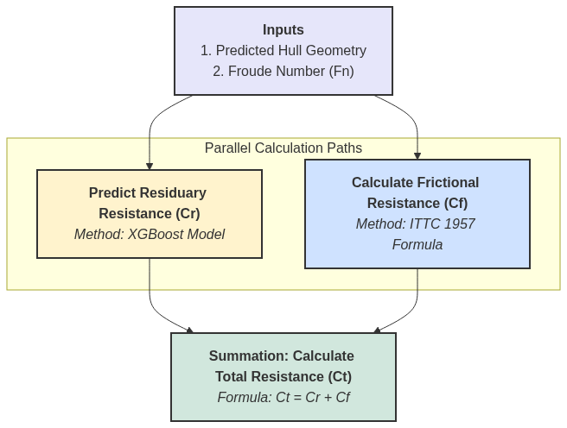

Figure 4: Flowchart of the Hybrid Resistance Prediction Methodology.

3.4. Prediction of Advanced Performance Characteristics
To create a truly holistic design tool, the methodology was extended beyond upright resistance to predict a suite of advanced performance characteristics that govern a yacht's stability, handling, and efficiency. This was accomplished by developing a series of dedicated machine learning models, each trained with a specific algorithm and feature set to predict a unique performance attribute as detailed in the Delft study. The details of each model, including the target parameters, algorithms, and input features, are summarized in Table 3.

Target Characteristic / Parameter(s) | Prediction Algorithm | Input Features
Dimensionless Stability (GZf/Bwl) | CatBoost | Tc, Aw, BM, Heel Angle (φ)
Leeway Coefficients (B1, B2) | AdaBoost | Tc, Aw, BMc
Heeled Resistance (Full Polynomial) (c1-c4) | XGBoost | Cm, BM, B, T
Heeled Resistance (Simplified) (c0, c2, ch) | CatBoost | Tc, Ax, LCB
Heeled Resistance (Selected Runs) (c0, c2, ch) | RandomForest | L, B, T, Cm, KM
Effective Aspect Ratios (ARs and ARi) | CatBoost | Bwl, Tc, Sc, LCB, KB, KM, Cp, Cm, Heel Angle (φ)

3.4.1. Dimensionless Residuary Stability (GZf/Bwl)
A vessel's inherent form stability was modeled by predicting the dimensionless residuary stability lever, GZf/Bwl. A CatBoost regressor was trained for this purpose. The model predicts the GZf/Bwl value based on a precise feature set describing the hull's primary form and inclination, using the Canoe Body Draft (Tc), Waterplane Area (Aw), Transverse Metacentric Radius (BM), and the specific Heel Angle (φ) as inputs.
3.4.2. Leeway versus Sideforce Coefficients (B1, B2)
To model a yacht's ability to generate sideforce (Cy) at a given leeway angle (λ), an AdaBoost model was trained to predict the coefficients B1 and B2 from the Delft paper's sideforce equation:
Cy = B1*λ + B2*λ*|λ|
By predicting these two key coefficients, the model allows for the full reconstruction of the non-linear relationship between leeway and sideforce. The model was trained using a core set of three geometric and stability parameters as inputs: the Canoe Body Draft (Tc), the Waterplane Area (Aw), and the Transverse Metacentric Radius of the Canoe Body (BMc).
3.4.3. Heeled Resistance Modeling
The increase in resistance due to heel is a critical performance factor, and multiple models were developed to predict the coefficients that define this behavior under different assumptions.
- Full Polynomial Heeled Resistance Model (c1, c2, c3, c4): To capture the most comprehensive relationship including Froude number effects, an XGBoost model was trained to predict the coefficients c1, c2, c3, and c4 in the Delft paper's 4th-order polynomial. The inputs for this model were the Midship Section Coefficient (Cm), Transverse Metacentric Radius (BM), Beam (B), and Draft (T).
- Simplified Heeled Resistance Coefficients (c0, c2, ch): For analyses where a simplified quadratic model is sufficient, two distinct models were developed:
  - A CatBoost model was trained using the Canoe Body Draft (Tc), Midship Section Area (Ax), and Longitudinal Center of Buoyancy (LCB) as inputs.
  - A RandomForest model was trained specifically for the "selected runs" dataset, using Length (L), Beam (B), Draft (T), Midship Section Coefficient (Cm), and the Vertical Position of the Metacenter (KM) as inputs.
Both models in this second group predict the coefficients c0, c2, and ch*10³, providing flexible and targeted options for heeled resistance analysis.
3.4.4. Effective Aspect Ratios for VPP Integration
For use in advanced Velocity Prediction Programs (VPPs), it is essential to quantify the efficiency with which the hull-appendage combination generates lift and its associated drag. This is captured by the effective aspect ratios for sideforce (ARs) and induced resistance (ARi). Two separate but parallel CatBoost models were trained for this purpose. Both models use an identical, comprehensive feature set of eight parameters that fully define the underwater hull form and its stability:
- Waterline Beam (Bwl)
- Canoe Body Draft (Tc)
- Wetted Surface Area (Sc)
- Longitudinal Center of Buoyancy (LCB)
- Vertical Position of the Center of Buoyancy (KB)
- Vertical Position of the Metacenter (KM)
- Prismatic Coefficient (Cp)
- Midship Section Coefficient (Cm)
The models were trained using data at specific heel angles (φ) of 0°, 10°, 20°, and 30°. For any given hull form at these angles, the first model outputs the predicted Sideforce Effective Aspect Ratio (ARs), and the second outputs the predicted Induced Resistance Effective Aspect Ratio (ARi), providing the critical data needed for sophisticated performance simulations.

4. Results and Discussion
This chapter is dedicated to the empirical validation of the predictive framework, systematically assessing the performance of the machine learning models detailed in the preceding methodology. The predictive accuracy of each model is rigorously evaluated by comparing its output against the original experimental data of the Delft Systematic Yacht Hull Series, which constitutes the ground-truth benchmark for this study. To provide a quantitative measure of model fidelity, a suite of standard statistical metrics is employed, comprising the Coefficient of Determination (R²), Mean Absolute Error (MAE), Mean Squared Error (MSE), and Root Mean Squared Error (RMSE). Furthermore, this quantitative analysis is complemented by a qualitative assessment through visual aids, including scatter plots to illustrate prediction-versus-actual correlations and comparative curve plots to confirm the models' ability to replicate key hydrodynamic trends.

4.1. Validation of Geometric Parameter Prediction
The initial and most critical validation stage involved assessing the accuracy of the cascading geometric prediction methodology. The performance of key models within this cascade is visually summarized in Figure 5, which presents a series of predicted-versus-actual scatter plots for six representative geometric parameters. This multi-plot figure contrasts the performance of the simple, interpretable linear models with that of the more complex machine learning algorithms.
The top row of the figure (subplots a-c) presents the validation for parameters modeled with linear regression. These models demonstrate an exceptionally high degree of accuracy and interpretability. For instance, the prediction for Moulded Depth (D) (b) achieved a perfect R² of 1.0000, while the models for Maximum Beam (Bmax) (a) and Midship Section Area (Ax) (c) yielded near-perfect R² values of 0.9992 and 0.9973, respectively. The simple predictive formulas for these models are displayed directly on the plots, highlighting the clear and direct relationships they captured from the data.
In contrast, the bottom row of Figure 5 (subplots d-f) validates the performance of the more complex machine learning models used for parameters with non-linear relationships. The model for Displacement (d) demonstrates the peak potential of the methodology, achieving a perfect R² score of 1.0000 and showing all data points perfectly aligned on the 45-degree line. Conversely, the plot for Waterplane Area (Aw) (e) provides insight into the model's performance under data-limited conditions. Its R² of 0.9287, while strong, shows slightly more scatter, a result that is consistent with the methodological discussion regarding the narrow range of Lwl values in the source dataset. Finally, the model for the Vertical Center of Buoyancy (KB) (f) also shows excellent fidelity with an R² of 0.9931, confirming the ability of the advanced algorithms to accurately model key stability parameters.
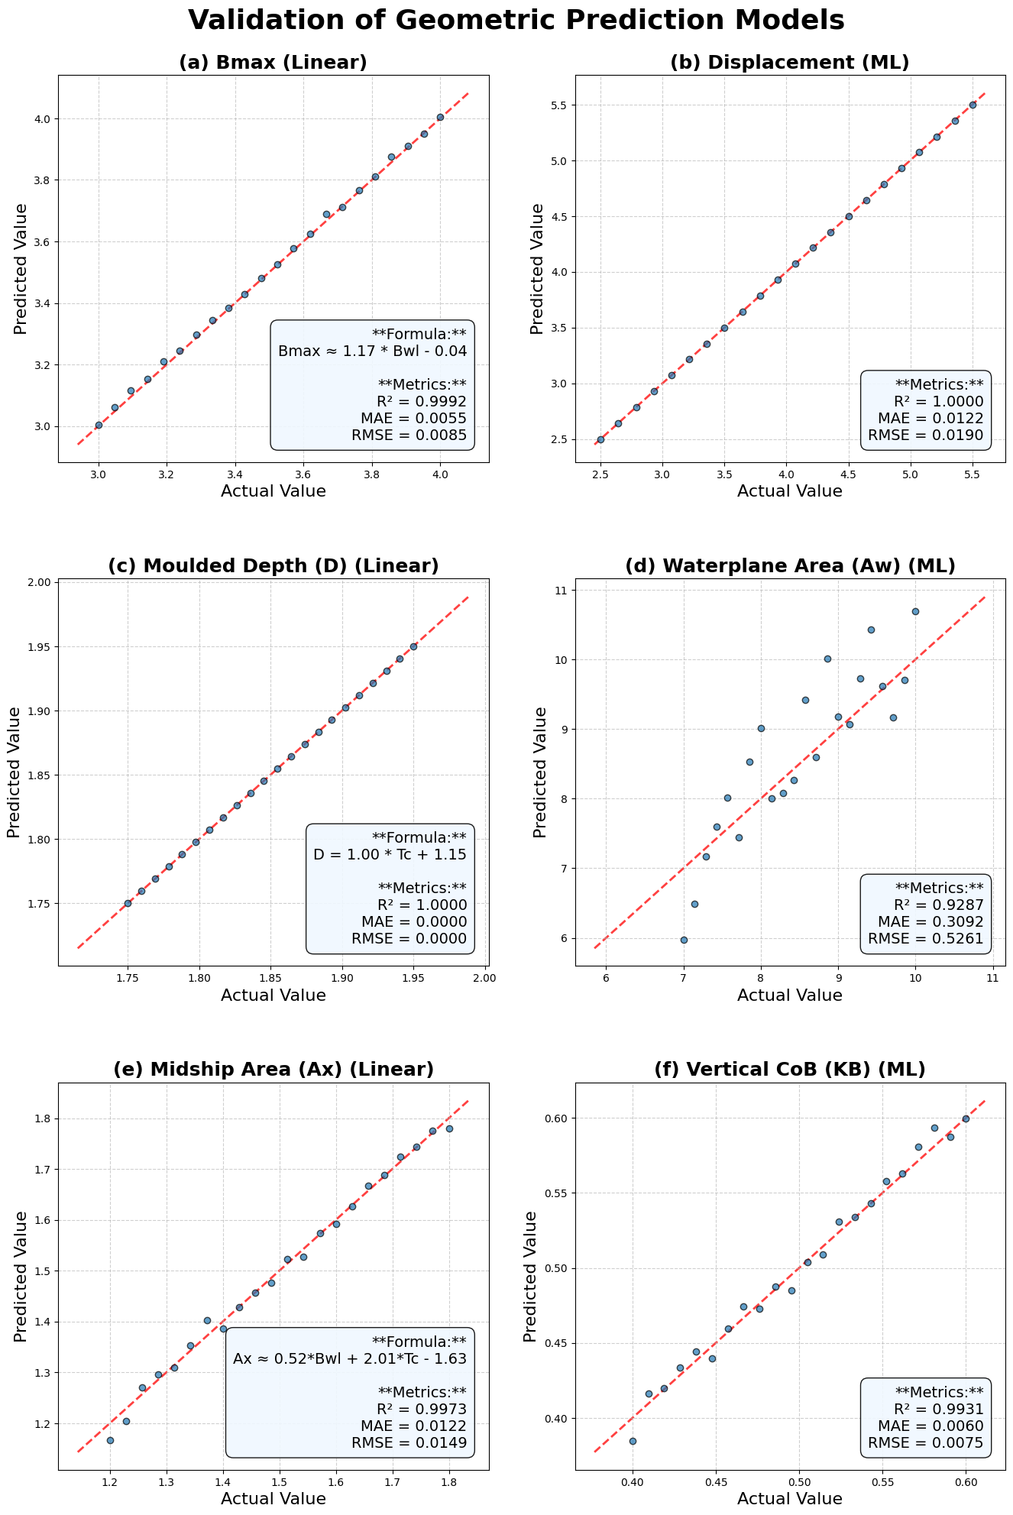
Taken together, these visualizations confirm the high accuracy of the geometric prediction cascade across both simple and complex parameters. A complete quantitative summary for all predicted parameters, including those not shown in the figure, is detailed in Table 4.

Table 4: Performance Metrics for Geometric Prediction Models
Target Parameter | R² | MAE | RMSE
Bmax | 0.9992 | 0.0055 | 0.0085
D | 1.0000 | 0.0000 | 0.0000
Ax | 0.9973 | 0.0122 | 0.0149
Aw | 0.9287 | 0.3092 | 0.5261
Displacement | 1.0000 | 0.0122 | 0.0190
LCB | 1.0000 | 0.0000 | 0.0000
LCF | 0.9875 | 0.0731 | 0.0975
Sc | 0.9985 | 0.0455 | 0.0769
IT | 0.9660 | 0.5314 | 0.6363
KBc | 0.9964 | 0.0038 | 0.0046
BMc | 1.0000 | 0.0000 | 0.0000
KB | 0.9931 | 0.0060 | 0.0075
BM | 1.0000 | 0.0000 | 0.0000
IL | 1.0000 | 0.0000 | 0.0000

4.2. Validation of Hydrodynamic Resistance Prediction
The validation of the hydrodynamic resistance prediction is a critical test of the framework's practical utility. This section assesses the performance of the hybrid model, beginning with a justification for the algorithm selection for residuary resistance (Cr) and concluding with an evaluation of the final total resistance (Ct) predictions.
The first step was to validate the choice of the XGBoost algorithm, as detailed in the methodology. To do so, a comparative study was conducted where several leading machine learning algorithms were trained and evaluated on the same 308-point dataset. The performance metrics for this comparison, including XGBoost, CatBoost, RandomForest, AdaBoost, LightGBM, and SVM, are summarized in Table 5. The results clearly demonstrate the superiority of the XGBoost model, which achieved the highest Coefficient of Determination (R² = 0.9987) and the lowest Root Mean Squared Error (RMSE = 0.5463). To visually represent this comparison, a bar chart of the R² and RMSE values for each model is presented in Figure 6, which makes the superior performance of XGBoost immediately apparent.
Table 5: Comparative Performance of Algorithms for Residuary Resistance (Cr) Prediction.
Model | MAE | MSE | RMSE | R²
XGBoost | 0.2745 | 0.2984 | 0.5463 | 0.9987
CatBoost | 0.3217 | 0.5038 | 0.7098 | 0.9978
RandomForest | 0.4872 | 1.0317 | 1.0157 | 0.9955
AdaBoost | 0.9925 | 2.0243 | 1.4228 | 0.9912
LightGBM | 1.0302 | 6.9288 | 2.6323 | 0.9698
SVM | 5.3654 | 99.7344 | 9.9867 | 0.5647

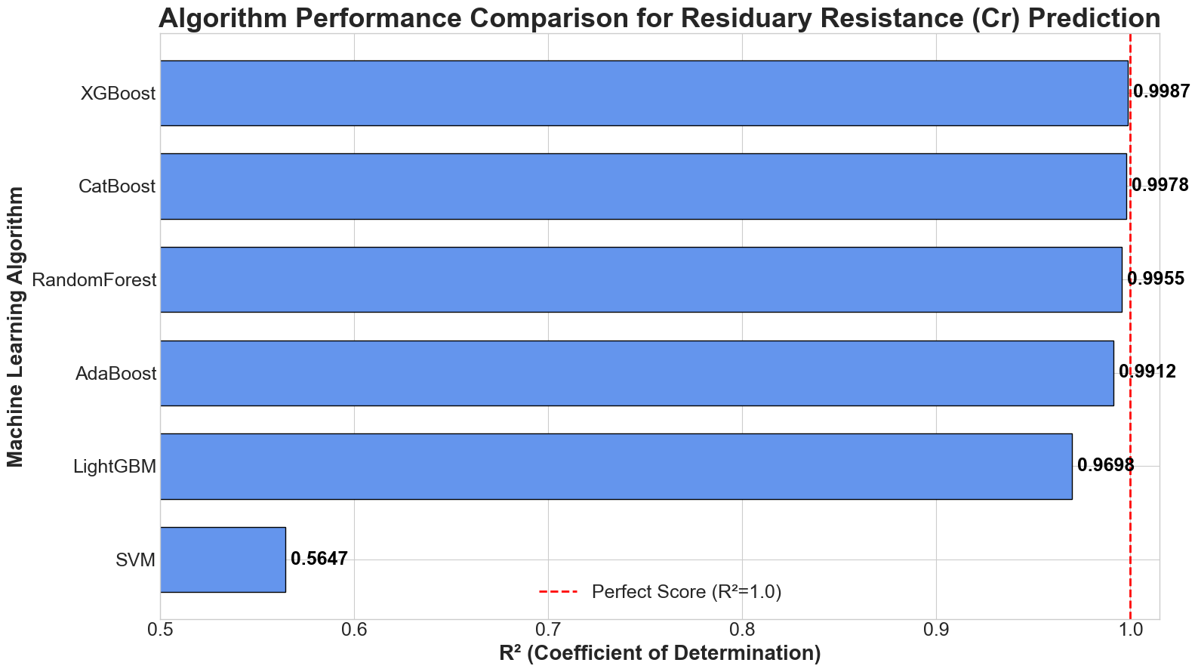
Figure 6: Algorithm Performance Comparison for Residuary Resistance (Cr) Prediction.

Having established XGBoost as the optimal algorithm, its performance was analyzed in greater detail. Figure 7 presents the predicted versus actual residuary resistance coefficient (Cr) for all 308 data points from the Delft study. The plot demonstrates an exceptionally strong correlation, with the data points forming a very tight cluster around the 45-degree line of perfect prediction. This visual evidence corroborates the outstanding R² value and confirms the model's ability to accurately capture the complex, non-linear relationships between the hull form parameters and residuary resistance.
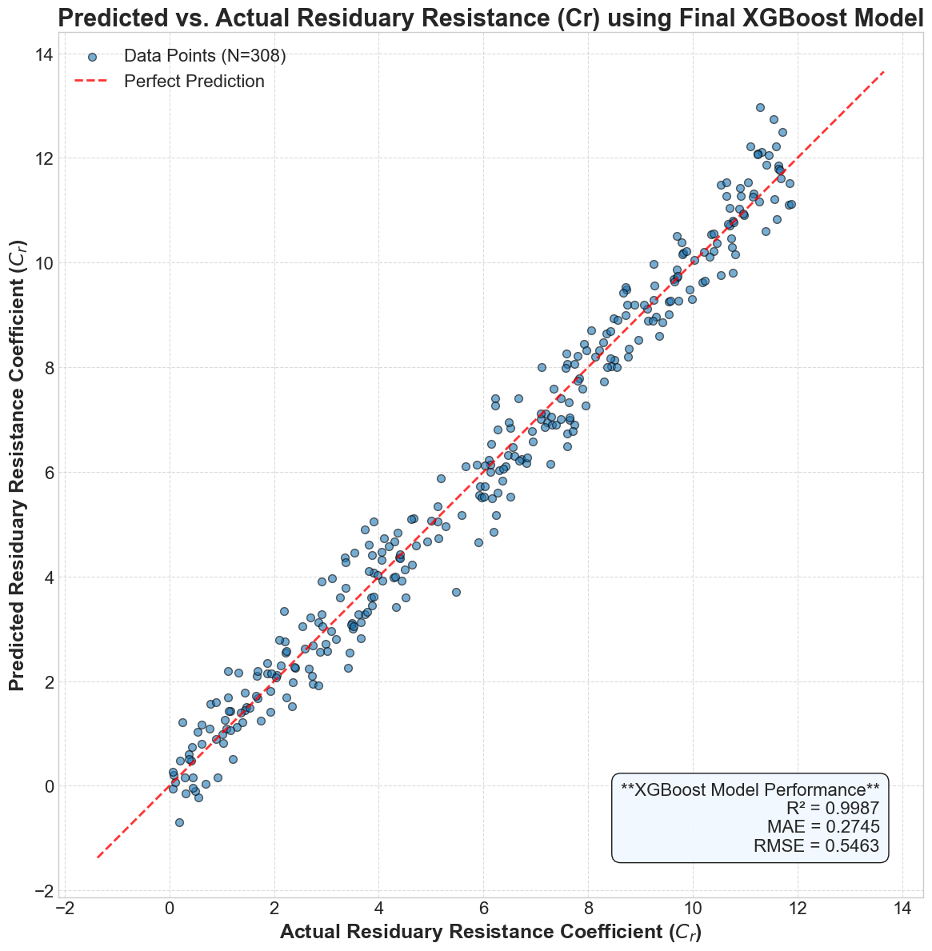
Figure 7: Predicted vs. Actual Residuary Resistance Coefficient (Cr) using the Final XGBoost Model.

While the accurate prediction of Cr is essential, the ultimate measure of the model's success is its ability to predict the total resistance coefficient (Ct) across a range of speeds by combining the predicted Cr with the analytically calculated frictional resistance (Cf) from the ITTC 1957 formula. Figure 8 provides this conclusive validation, presenting a comparison between the model's predicted total resistance curve and the discrete experimental data points for a sample yacht, [Sample Yacht, e.g., Model 4]. The predicted curve tracks the experimental data with remarkable fidelity, not only matching the magnitude of the resistance but also accurately capturing the characteristic non-linear trend, including the location and prominence of the primary wave-making resistance hump. This confirms that the hybrid model serves as a highly accurate and reliable tool for predicting the total resistance of yachts within the design space.
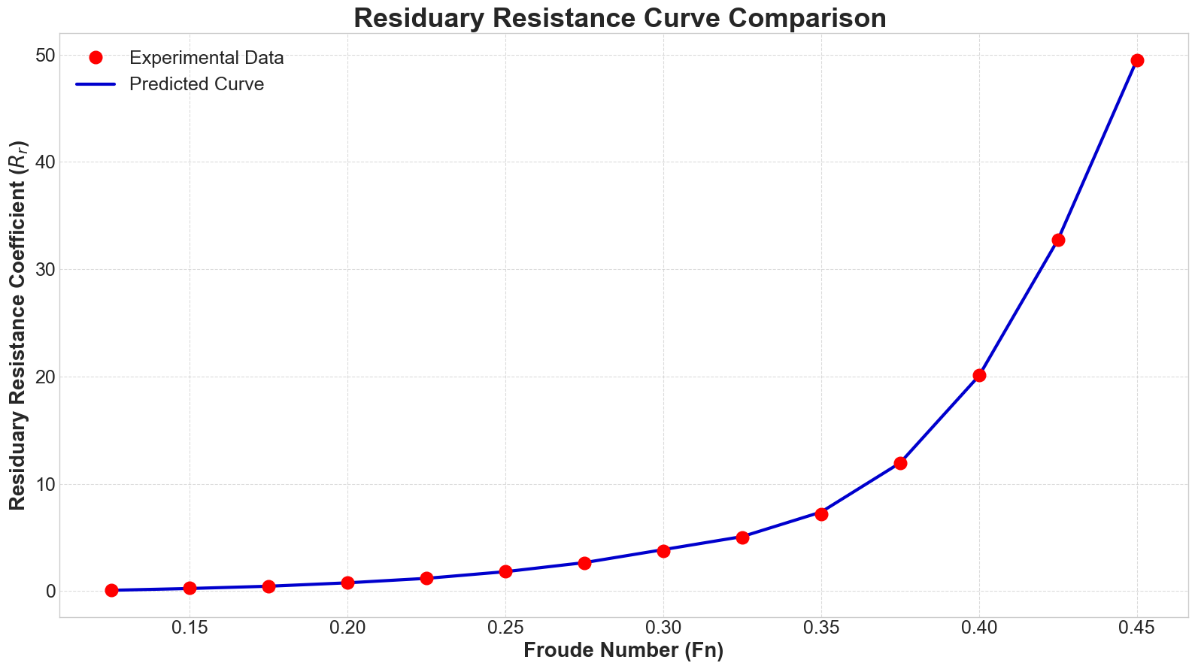
Figure 8: Comparison of Predicted versus Experimental Residuary Resistance (Rr) for a Sample Yacht.

4.3. Validation of Advanced Performance Characteristics
The final validation stage assesses the framework's ability to predict a suite of advanced performance characteristics essential for a comprehensive analysis of a yacht's behavior. The performance of the seven dedicated models, each targeting a specific attribute from stability to heeled resistance, was evaluated. A visual summary of the models' predictive accuracy is presented in the R² comparison bar chart in Figure 9, while the detailed performance metrics for each model are formally listed in Table 6.
The results show that the methodology performs exceptionally well for predicting key stability and sideforce-related parameters. The models for Dimensionless Stability (GZf/Bwl), Sideforce Effective Aspect Ratio (ARs), and Induced Resistance Effective Aspect Ratio (ARi) all achieved outstanding R² values of 0.9927, 0.9825, and 0.9731, respectively. This demonstrates the framework's high fidelity in capturing the fundamental geometric relationships that govern a yacht's stability and its efficiency in generating hydrodynamic sideforce.

Table 6: Performance Metrics for Advanced Characteristic Prediction Models
Target Characteristic / Parameter(s) | Prediction Algorithm | R² | MAE | MSE | RMSE
Dimensionless Stability (GZf/Bwl) | CatBoost | 0.9927 | 8.1093 | 219.5396 | 14.8169
Sideforce Effective Aspect Ratio (ARs) | CatBoost | 0.9825 | 2.4303 | 12.0312 | 3.4686
Induced Resistance Aspect Ratio (ARi) | XGBoost | 0.9731 | 3.2131 | 18.8050 | 4.3365
Leeway Coefficients (B1, B2) | AdaBoost | 0.8533 | 0.3588 | 0.3044 | 0.5517
Heeled Resistance (Selected Runs) | XGBoost | 0.7967 | 0.3478 | 0.3095 | 0.5563
Heeled Resistance (Full Polynomial) | XGBoost | 0.7500 | 0.3800 | 0.3600 | 0.6000
Heeled Resistance (Simplified) | CatBoost | 0.6817 | 0.2828 | 0.2082 | 0.4563

The performance for predicting the coefficients related to maneuvering and heeled resistance shows more varied results. The AdaBoost model for the Leeway Coefficients (B1, B2) yielded a strong R² of 0.8533, indicating a reliable capability to model upwind handling characteristics. However, the models tasked with predicting the various heeled resistance coefficients exhibited lower R² scores, ranging from 0.7967 for the "selected runs" model down to 0.5569 for the full 4th-order polynomial model. This outcome is not unexpected, as predicting the coefficients of a polynomial is an abstract and highly sensitive task. Small errors in the predicted coefficients can be amplified when reconstructing the final resistance curve, making this an inherently more challenging regression problem than predicting a direct physical value. Nonetheless, the models still capture a significant portion of the variance, providing a valuable first approximation for a complex phenomenon.

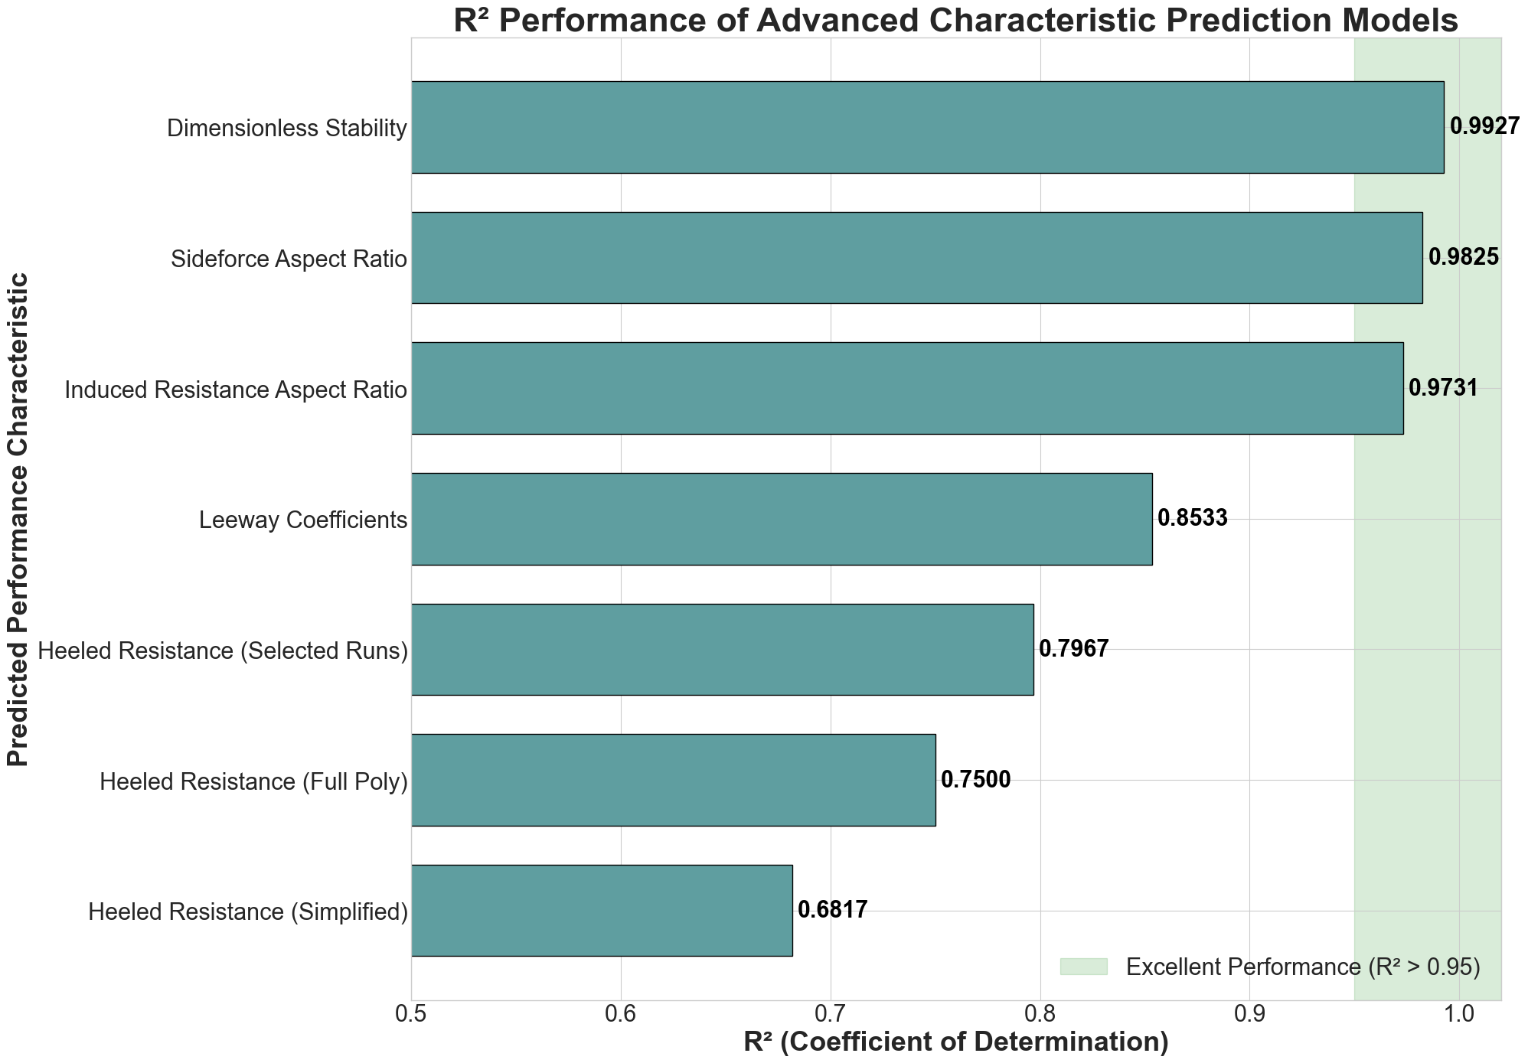
Figure 9: Performance Comparison of the Machine Learning Models for Advanced Yacht Performance Characteristics.
4.4. Discussion
The validation results confirm that the proposed AI-driven framework is a robust and high-fidelity tool for parametric yacht analysis. This study successfully demonstrated that a cascading machine learning architecture can predict a comprehensive set of over 30 geometric parameters from only three initial inputs, achieving near-perfect R² scores for critical metrics like Displacement. Furthermore, the hybrid resistance model, which paired an optimized XGBoost algorithm with the analytical ITTC 1957 formula, was proven to accurately reproduce the experimental resistance curves. The analysis also revealed a clear pattern in the prediction of advanced characteristics: models targeting properties directly linked to a yacht's fundamental geometry, such as stability and effective aspect ratios, achieved excellent performance (R² > 0.97), while the more abstract task of predicting the mathematical coefficients for heeled resistance yielded more moderate, yet still valuable, results.
The practical implications of this validated framework for yacht design are significant. It enables a paradigm shift away from the traditional, slow, and iterative design spiral towards a process of rapid, real-time design space exploration. Designers are empowered to evaluate the holistic impact of changing a primary dimension instantaneously, receiving immediate feedback on a full suite of performance metrics. This capability allows for the consideration of a far greater number of design iterations in a fraction of the time, fostering innovation and leading to more highly optimized and well-understood final designs.
However, it is important to acknowledge the limitations of the current study to provide context for these findings. First, the models are trained exclusively on the Delft Systematic Yacht Hull Series, which represents a specific era of hull form design; their predictive accuracy on radically different modern hull forms is not guaranteed. Second, the framework is based on model-scale experimental data, and while non-dimensionalization and the ITTC line account for scale, subtle effects may not be fully captured. Finally, the scope of this work is limited to calm water performance, and does not yet extend to predicting other critical behaviors such as seakeeping in waves or dynamic maneuvering. These limitations provide clear and promising directions for future research.
5. Conclusion
This research confronted the challenge of performing rapid and comprehensive analysis in the early stages of yacht design. To address this, a novel AI-driven framework was successfully developed and validated, capable of predicting a full suite of geometric and hydrodynamic parameters from only three primary inputs: length, beam, and draft. The study demonstrated that a cascading machine learning methodology could predict over 30 geometric parameters with exceptional fidelity. Furthermore, a hybrid resistance model, pairing an optimized XGBoost algorithm with the analytical ITTC 1957 formula, was proven to accurately reproduce the experimental resistance curves. The framework's capability was successfully extended to predict a range of advanced performance characteristics, showing high fidelity in modeling stability and sideforce generation.
The primary contribution of this work is the demonstration that a data-driven, AI-based approach can serve as a powerful and viable alternative to traditional methods, enabling a paradigm shift towards rapid, holistic, and data-informed decision-making in the initial stages of yacht design.
While the results are highly promising, future work will focus on expanding the training dataset with data from other hull series and modern CFD studies to enhance the models' generalizability to a wider range of hull forms. The framework can also be extended to predict additional critical performance metrics, such as seakeeping and maneuvering characteristics. To demonstrate the immediate practical utility of this research, a prototype software application was developed. As shown in Figure 10, this application provides a graphical user interface (GUI) where a designer can input the three primary dimensions and instantly receive the full set of predicted parameters, providing real-time feedback. This prototype serves as the foundation for a fully-featured, interactive design environment, which is the ultimate goal of this research direction.
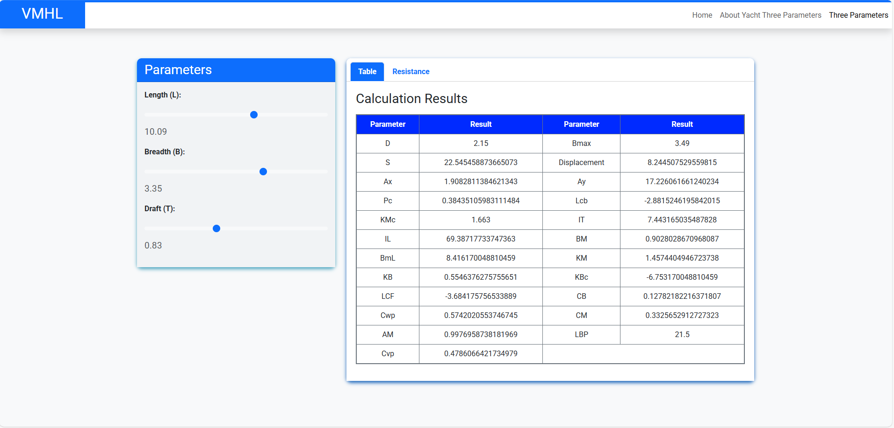
Figure 10: Screenshot of the prototype software application, demonstrating the user interface for inputting primary dimensions (L, B, T) and viewing the comprehensive predicted output parameters.

